
School of Computer Science, Engineering and Applications (SCSEA)
B.Tech TY (CCSA)
Subject : Cloud Architecture & Services (P)
Name of the Student: | ANUJ DIXIT | PRN | 20240802203
Title of Practical : | Access S3 from Private EC2 Instance using VPC Endpoints
Faculty Name: | Ms.Tahreem Shaikh | Sign:

Title
Access S3 from Private EC2 Instance using VPC Endpoints
Aim
To create a private Amazon EC2 environment and access an Amazon S3 bucket through an S3 VPC Gateway Endpoint without using a public IP address or Internet Gateway.
Objectives
- Create a VPC.
- Create a private subnet.
- Create and associate a route table.
- Create a security group.
- Create an S3 bucket.
- Create an S3 Gateway VPC Endpoint.
- Create SSM Interface Endpoints.
- Create an IAM role for EC2.
- Launch a private EC2 instance.
- Connect to EC2 using Session Manager.
- Access the S3 bucket from the private EC2 instance.
- Verify CSV file access through the S3 Gateway Endpoint.
AWS Services Used
- Amazon VPC
- Amazon EC2
- Amazon S3
- VPC Gateway Endpoint
- VPC Interface Endpoints
- AWS IAM
- AWS Systems Manager Session Manager
Prerequisites
- AWS account.
- AWS Management Console access.
- AWS region: ap-northeast-3 (Osaka).
- Required AWS permissions.
- S3 test file: amazon_macie_fake_dataset.csv.
Architecture Diagram

AWS VPC: 2203-vpc-01
10.0.0.0/16
|
|
Private Subnet
2203-private-subnet
10.0.1.0/24
|
|
Private EC2 Instance
10.0.1.112
|
+-------------------+-------------------+
| |
| |
SSM Interface S3 Gateway
Endpoints Endpoint
| |
| |
Session Manager Route Table
|
|
Amazon S3
2203-private-s3
|
|
amazon_macie_fake_dataset.csv
Architecture explanation
The EC2 instance is placed inside a private subnet and has no public IPv4 address. Session Manager uses the three SSM Interface Endpoints to connect to the instance. S3 traffic uses the S3 Gateway Endpoint associated with the private route table. The private design has no Internet Gateway route and no public IP.

Step-by-Step Implementation
Step 1: Create VPC
Procedure
- Open AWS Management Console.
- Search for VPC.
- Open VPC Dashboard.
- Click Your VPCs.
- Click Create VPC.
- Select VPC only.
Enter:
Field | Value
Name | 2203-vpc-01
IPv4 CIDR | 10.0.0.0/16
Tenancy | Default
Click Create VPC. 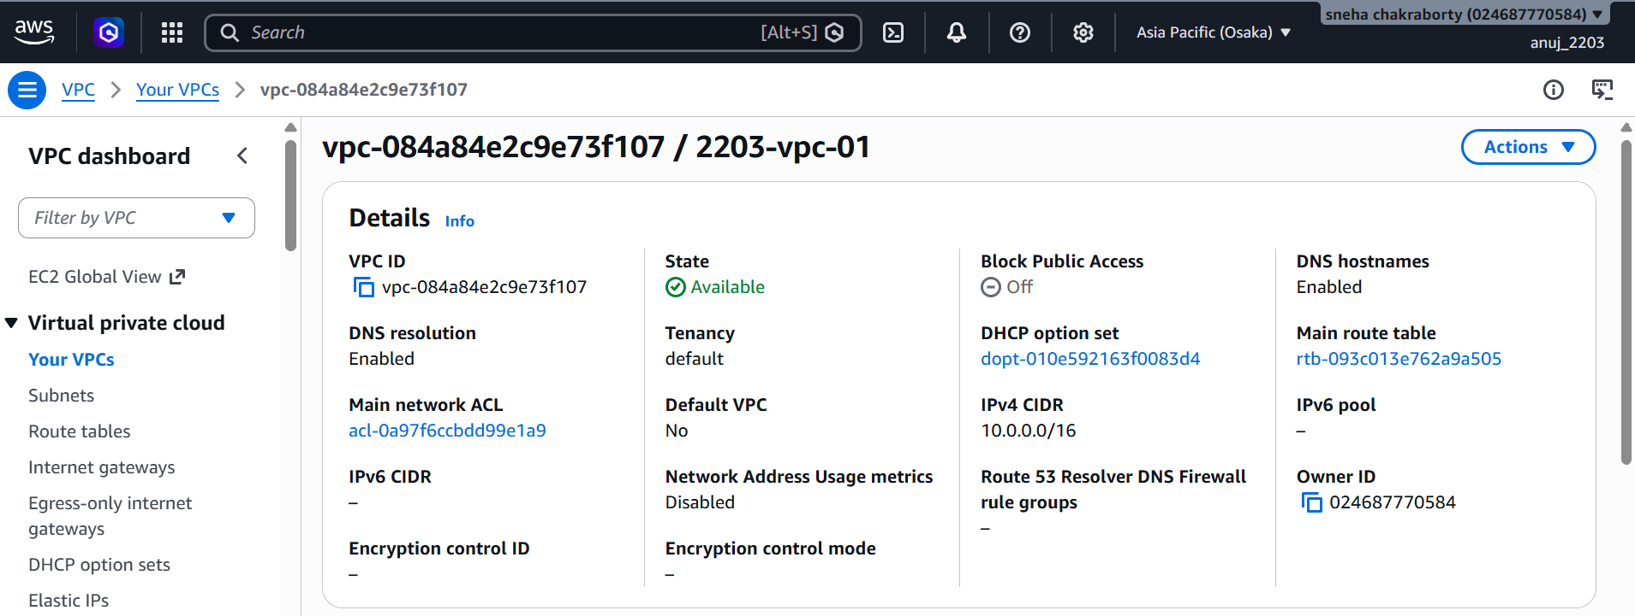
The source practical requires a VPC with a /16 CIDR and DNS resolution/hostnames enabled.
Step 2: Create Private Subnet
Procedure
- Open VPC → Subnets.
- Click Create subnet.
- Select VPC: 2203-vpc-01
- Enter subnet name: 2203-private-subnet
- Select Availability Zone: ap-northeast-3a
- Enter IPv4 CIDR: 10.0.1.0/24
- Create the subnet.
- Select the subnet.
- Open Actions → Edit subnet settings.
- Make sure Auto-assign public IPv4 address is disabled.
Important: Do not create an Internet Gateway or NAT Gateway for this private subnet.
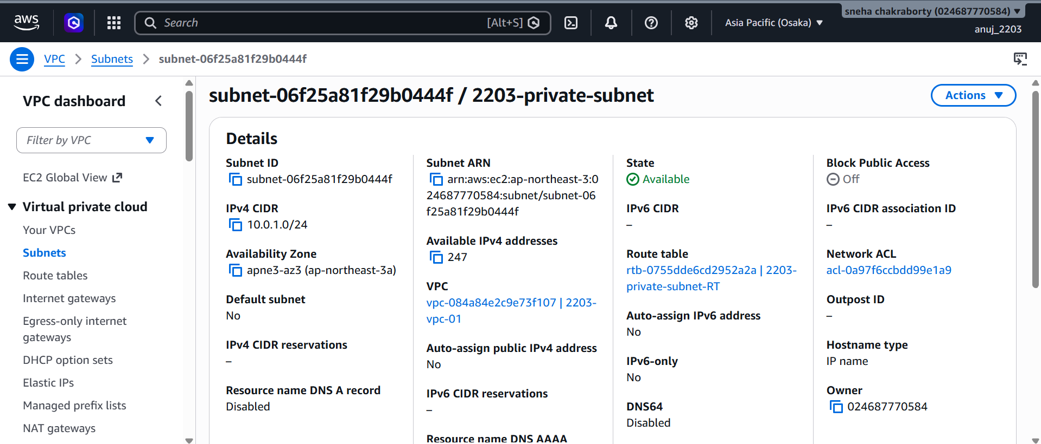
Capture: Subnet name, VPC, Availability Zone, IPv4 CIDR, Public IPv4 setting.
Step 3: Create Route Table
Procedure
- Open VPC → Route Tables.
- Click Create route table.
Enter:
Field | Value
Name | private route table
VPC | 2203-vpc-01
- Click Create route table.
- Select the route table.
- Open Subnet associations.
- Click Edit subnet associations.
- Select: 2203-private-subnet
- Click Save associations.

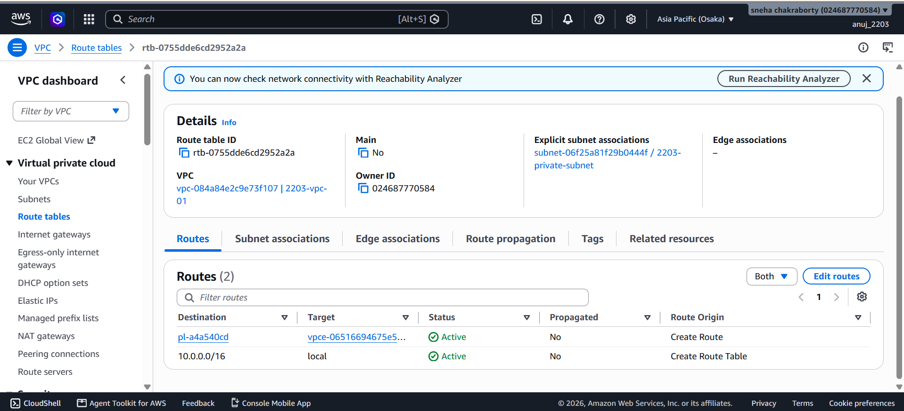
Capture: Route table name, VPC, Subnet association.
The practical requires the private subnet to be associated with the private route table.
Step 4: Create Security Group
Procedure
- Open EC2 Console.
- Go to Security Groups.
- Click Create security group.
Enter:
Field | Value
Security group name | 2203-s3-TG
Description | ssm and s3 only
VPC | 2203-vpc-01
- Configure the required HTTPS/443 access for the SSM interface endpoints.
- Keep outbound traffic available for HTTPS communication.
- Click Create security group.

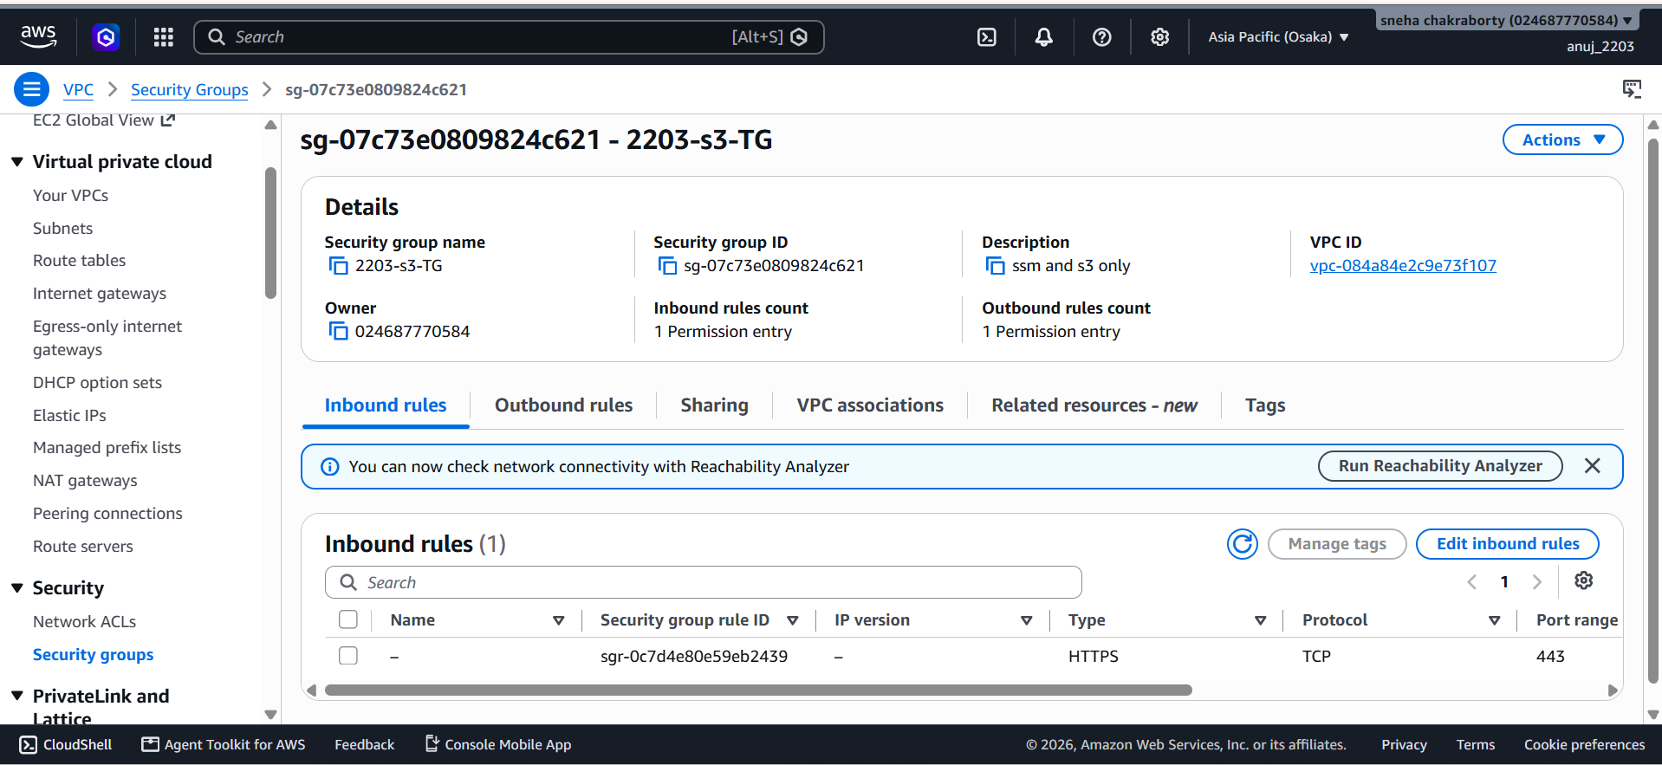
Capture: Security group name, VPC, Inbound rule, Outbound rule.
The source practical notes that the basic EC2 security group does not need SSH because Session Manager is used instead.
Step 5: Create S3 Bucket
Procedure
- Open Amazon S3.
- Click Create bucket.
Enter bucket name: 2203-private-s3
Select region: ap-northeast-3
- Keep other settings default.
- Click Create bucket.
- Open the bucket.
- Click Upload.
- Upload: amazon_macie_fake_dataset.csv
- Click Upload.

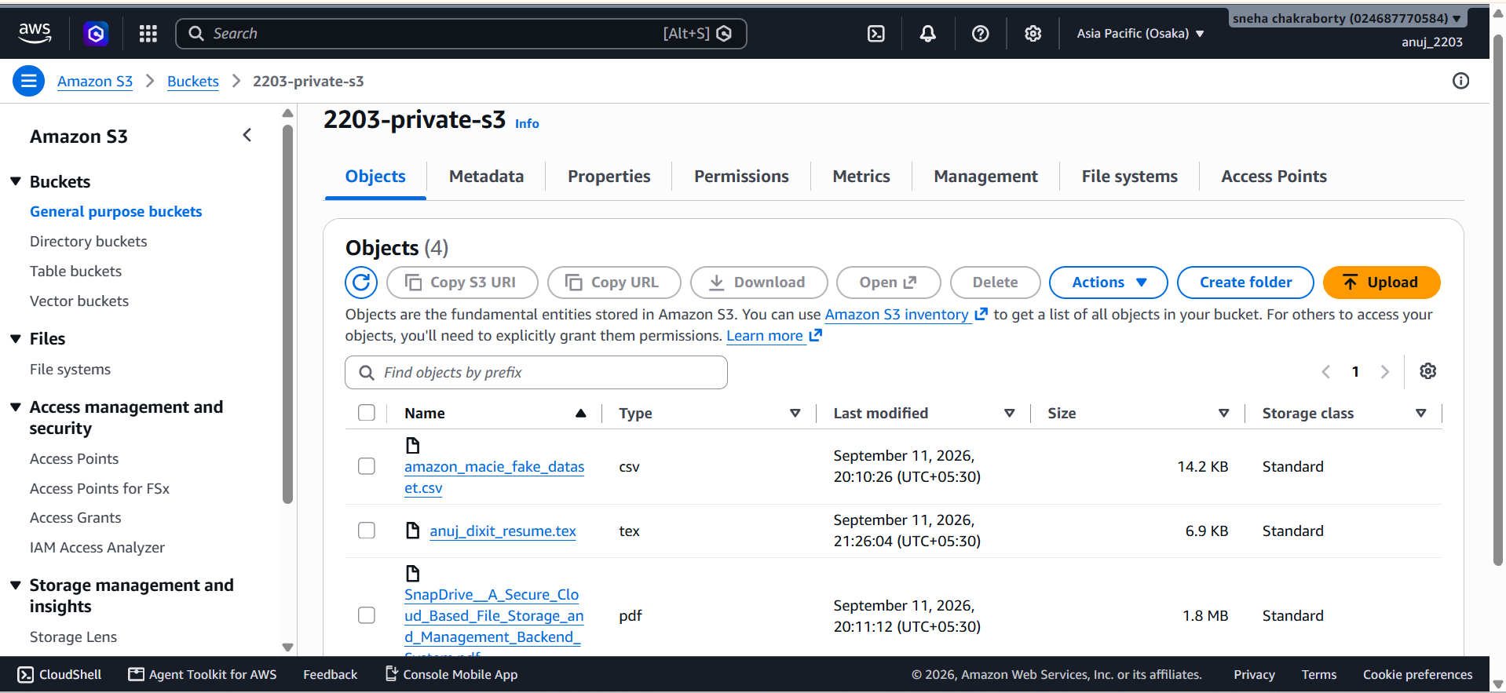
Capture: Bucket name, Region, Uploaded CSV file.
The practical requires the bucket to be in the same region and a test object to be uploaded.
Step 6: Create S3 Gateway Endpoint
Procedure
- Open VPC Console.
- Select Endpoints.
- Click Create endpoint.
- Enter endpoint name, for example: 2203-s3-gateway-endpoint
- Select: Service category → AWS services
- Search for S3.
- Select: com.amazonaws.ap-northeast-3.s3
- Make sure endpoint type is: Gateway
- Select VPC: 2203-vpc-01
- Select your private route table.
- Keep policy as Full access for the initial test.
- Click Create endpoint.

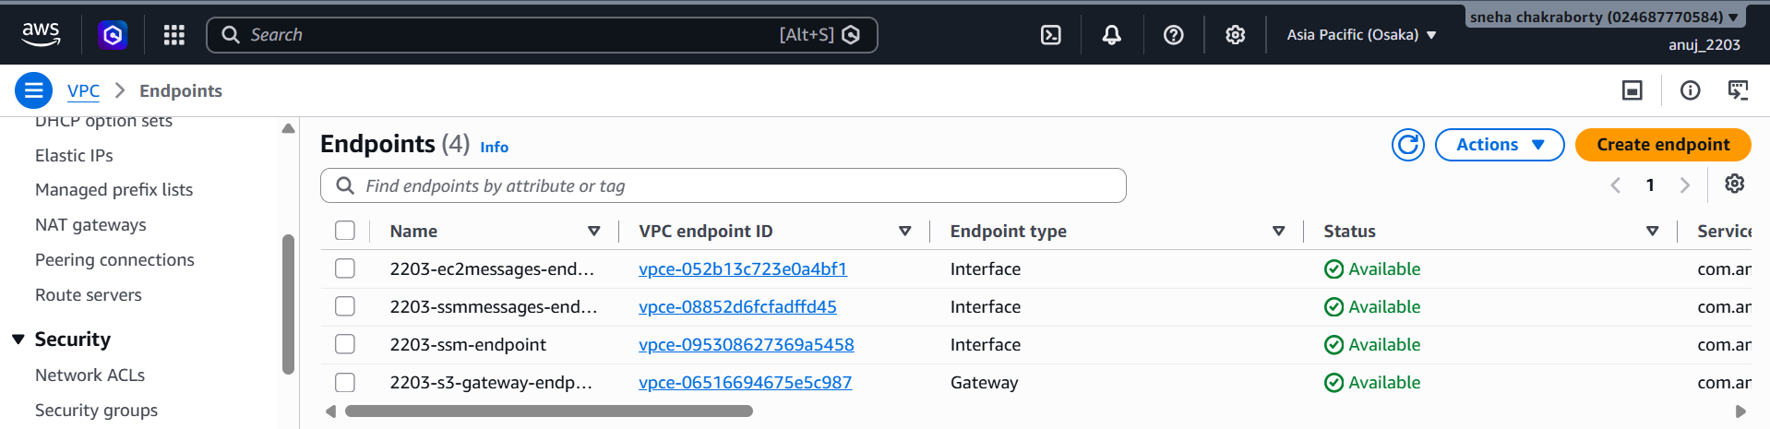
Capture: Endpoint name, Service name, Type = Gateway, VPC, Route table.

Step 7: Verify S3 Route
After creating the S3 Gateway Endpoint:
- Go to VPC → Route Tables.
- Select the private route table.
- Open the Routes tab.
- You should see an S3 prefix-list route.
- The target should be the S3 Gateway Endpoint.
Example:
Field | Value
Destination | pl-xxxxxxxx
Target | vpce-xxxxxxxx
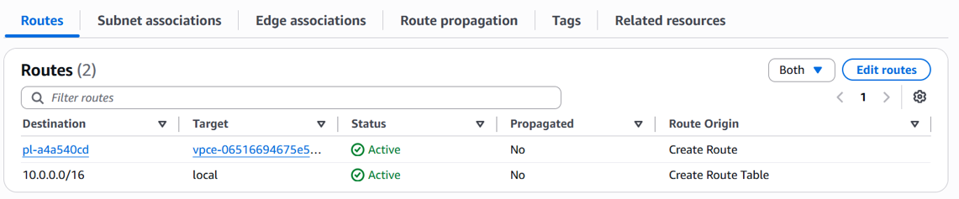
This is an important screenshot because it demonstrates that S3 traffic is routed through the Gateway Endpoint.
Step 8: Create SSM Interface Endpoints
Three Interface Endpoints are required:
- Endpoint 1 — com.amazonaws.ap-northeast-3.ssm
- Endpoint 2 — com.amazonaws.ap-northeast-3.ssmmessages
- Endpoint 3 — com.amazonaws.ap-northeast-3.ec2messages
For each endpoint
- Go to VPC → Endpoints.
- Click Create endpoint.
- Select AWS services.
- Select the required SSM service.
- Select Type: Interface
- VPC: 2203-vpc-01
- Subnet: 2203-private-subnet
- Security Group: 2203-s3-TG
- Keep Private DNS enabled.
- Click Create endpoint.
- Repeat for all three services.

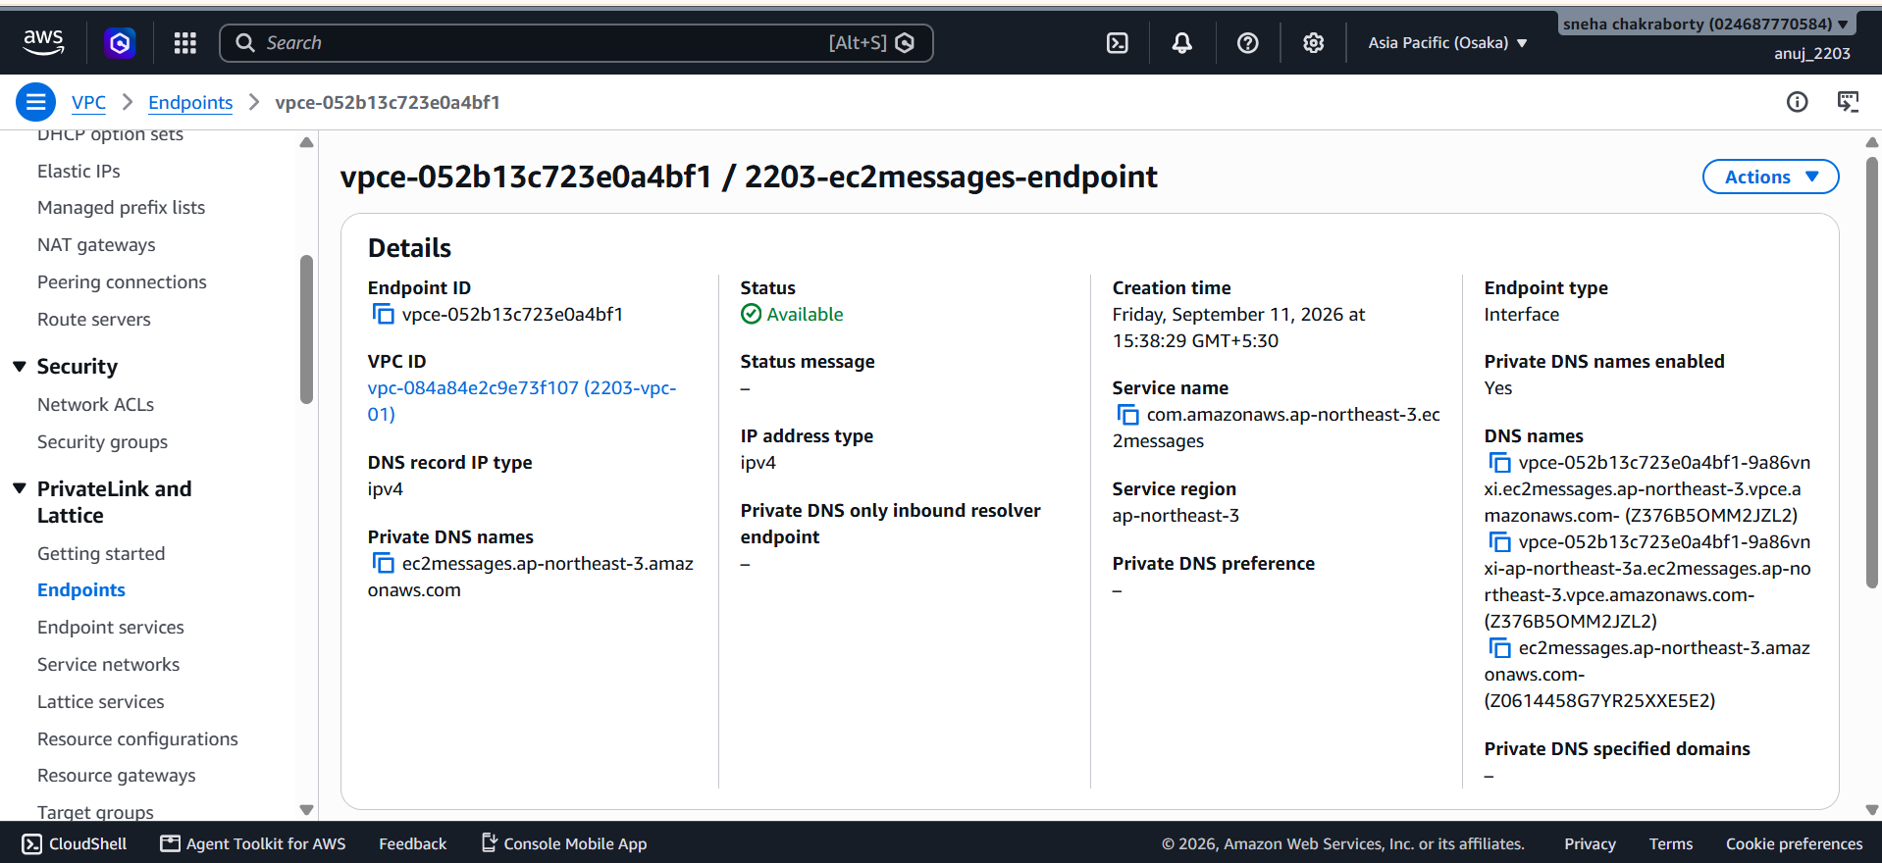

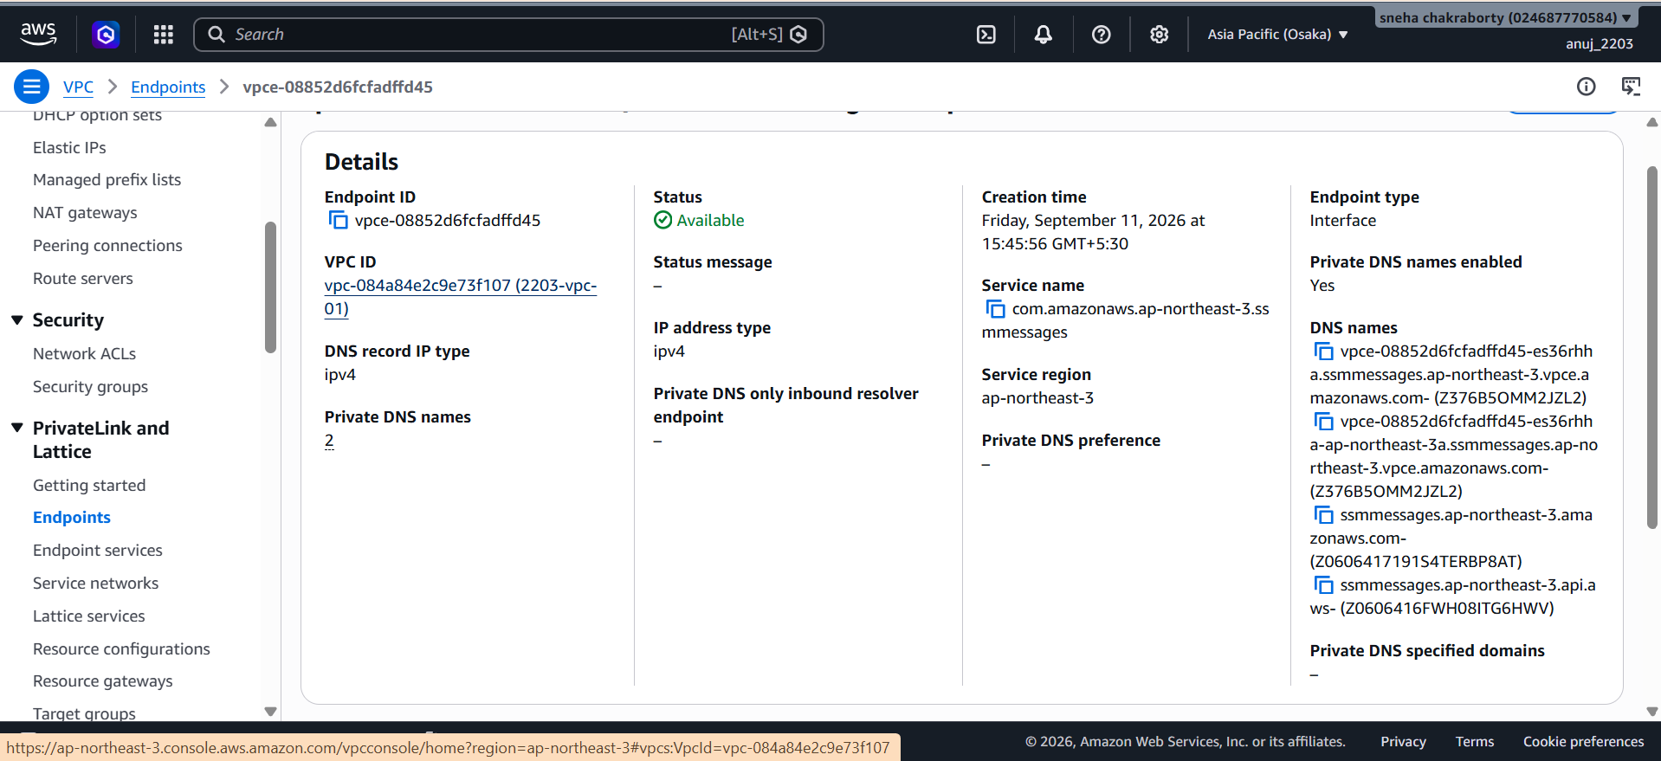

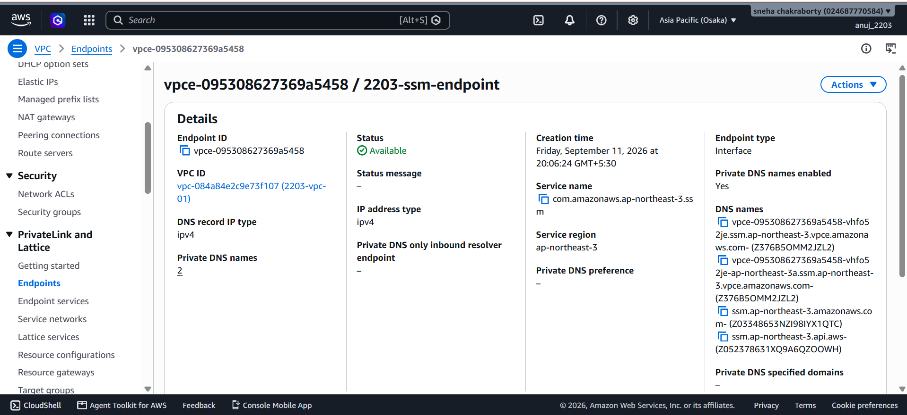

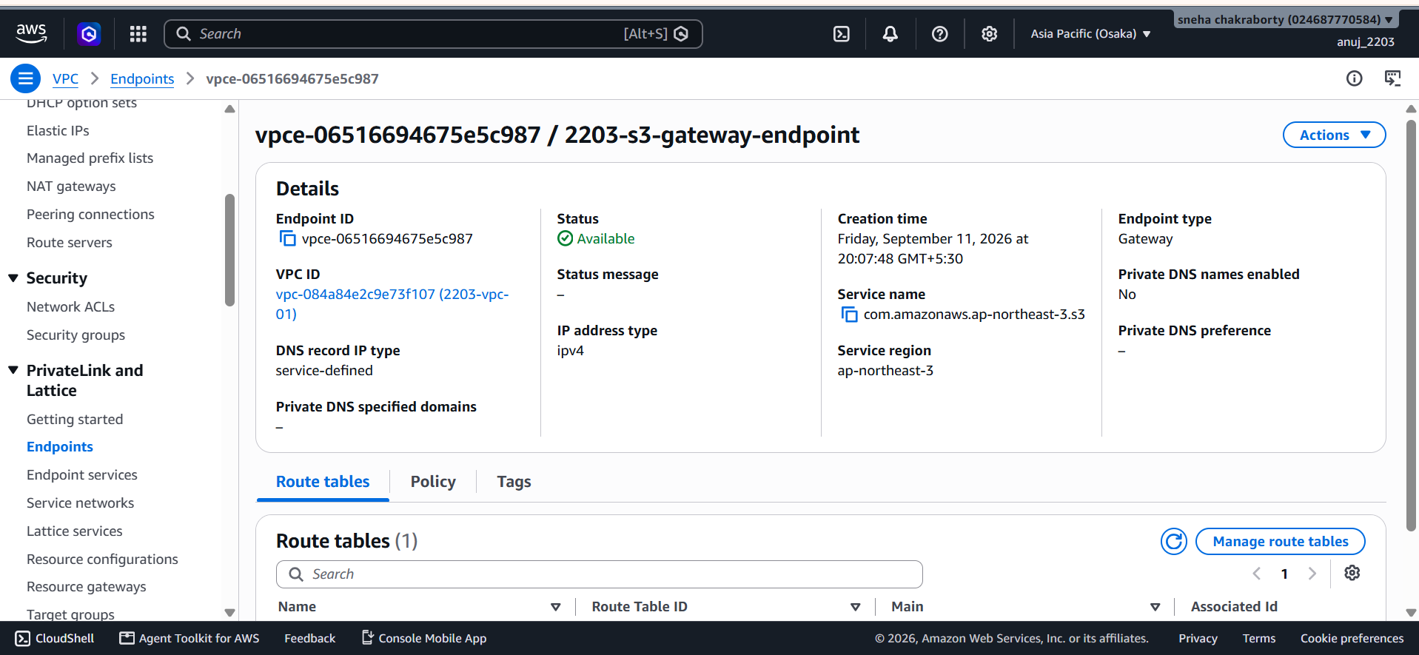
Capture the endpoint list showing: ssm, ssmmessages, ec2messages.
The practical requires all three Interface Endpoints and Private DNS enabled.
Step 9: Create IAM Role
Procedure
- Open IAM Console.
- Go to Roles.
- Click Create role.
- Select Trusted entity: AWS service
- Use case: EC2
Attach:
- AmazonS3ReadOnlyAccess
- AmazonSSMManagedInstanceCore
Role name: 2203-private-ec2-s3-role
Click Create role.

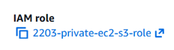
Show: Role name, AmazonS3ReadOnlyAccess, AmazonSSMManagedInstanceCore.
Step 10: Launch Private EC2 Instance
Procedure
- Open EC2 → Instances.
- Click Launch instances.
Enter:
- Name: 2203-private-s3-demo-instance
- Amazon Linux 2023
- Instance type: t3.micro
- Key pair: Proceed without a key pair
Under Network Settings click Edit. Select:
- VPC: 2203-vpc-01
- Subnet: 2203-private-subnet
- Auto-assign Public IP: Disable
- Security Group: 2203-s3-TG
Under Advanced details, select:
- IAM instance profile: 2203-private-ec2-s3-role
Click Launch instance. Wait until:
- Instance state: Running
- Status checks: 2/2
Your actual instance
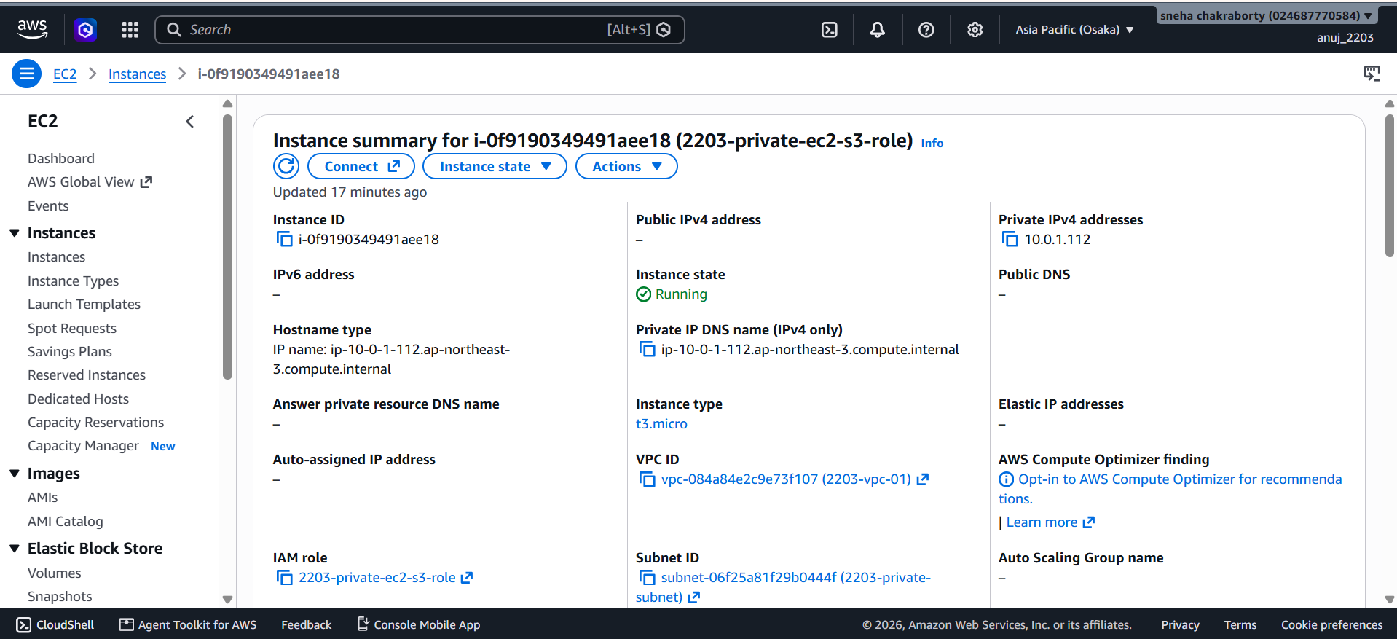

Capture: Instance ID, Running state, Private IPv4, No Public IPv4, VPC, Subnet, IAM role.
The source practical specifies Amazon Linux 2023, t3.micro, no key pair, disabled public IP, the private subnet, security group and IAM role.
Step 11: Connect Using Session Manager
Procedure
- Select: i-0f9190349491aee18
- Click Connect.
- Select Session Manager.
- Click Connect.
- Wait for the browser terminal to open.
No SSH key or public IP is required.

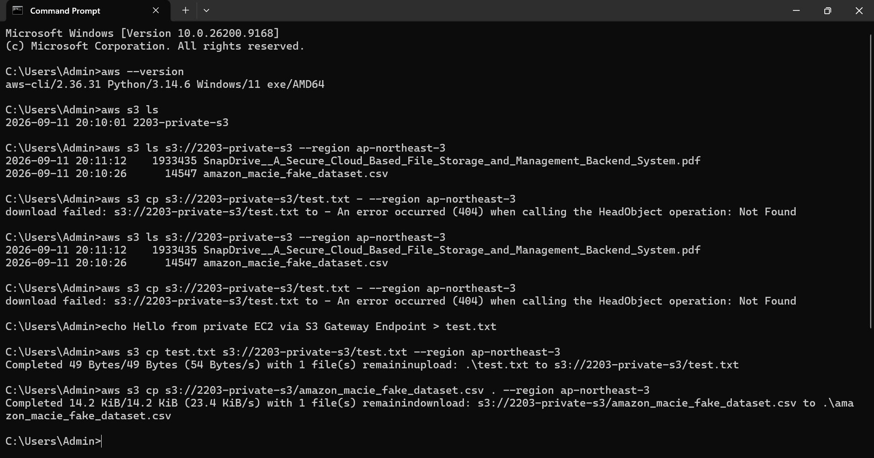
Capture the connected Session Manager terminal.
Step 12: Test S3 Access
Inside the Session Manager terminal, run:
aws --version
Then:
aws s3 ls s3://2203-private-s3 --region ap-northeast-3
You should see:
amazon_macie_fake_dataset.csv

Step 13: Download CSV From S3
Inside the Session Manager terminal:
aws s3 cp s3://2203-private-s3/amazon_macie_fake_dataset.csv . --region ap-northeast-3
Then verify:
ls -lh amazon_macie_fake_dataset.csv
You should see the downloaded file.
Capture: aws s3 cp ..., ls -lh amazon_macie_fake_dataset.csv
This confirms that the private EC2 instance can access an S3 object through the S3 Gateway Endpoint.

Verification / Testing
The following tests were performed:
Test 1 — EC2
- Instance State: Running
- Public IPv4: None
- Private IPv4: 10.0.1.112
Test 2 — Session Manager
Session Manager successfully connected to the private EC2 instance.
Test 3 — S3 Listing
Command:
aws s3 ls s3://2203-private-s3 --region ap-northeast-3
Result:
amazon_macie_fake_dataset.csv
Test 4 — S3 Object Download
Command:
aws s3 cp s3://2203-private-s3/amazon_macie_fake_dataset.csv . --region ap-northeast-3
Result: Download successful
Test 5 — Local File Verification
Command:
ls -lh amazon_macie_fake_dataset.csv
Result:
amazon_macie_fake_dataset.csv
Test 6 — Route Verification
The private route table contains the S3 prefix-list route targeting the S3 Gateway Endpoint.
Result / Conclusion
Result:
The private AWS environment was successfully created and configured. The EC2 instance was launched without a public IPv4 address and was accessed using AWS Systems Manager Session Manager. The S3 Gateway VPC Endpoint was successfully configured with the private route table. The private EC2 instance successfully accessed the S3 bucket and downloaded the amazon_macie_fake_dataset.csv file.
Conclusion:
The practical successfully demonstrates private EC2-to-S3 communication using an S3 VPC Gateway Endpoint, without requiring a public IP address or Internet Gateway route. Session Manager provided private administrative access through the SSM Interface Endpoints. This matches the practical's intended architecture and verification process.

